**Remote system connectivity using computer vision**

**Business Requirements Document**

**Prepared for**



<https://hersecondinnings.com/>

**Prepared by**

**HSI BATCH 6 Returnship Team**

For internal use only

Document Control

Change Record

| Date | Author | Version | Change Reference |
| --- | --- | --- | --- |
|  |  |  |  |
| 01/06/2021 | Amita  Julie  Shailaja | 1.0 | Initial version |
|  |  |  |  |
|  |  |  |  |
|  |  |  |  |
|  |  |  |  |

Participants

Contributors

| Name | Representing | Role |
| --- | --- | --- |
| Vrinda | HSI | Business PM |
| Nisha | HSI | Business Analyst |
| Shailaja | HSI | IT Analyst + Developer |
| Julie | HSI | IT Analyst + Developer |
| Amita | HSI | IT Analyst + Developer |

Reviewers/Approvers

| Name | Representing | Role | Approval Date |
| --- | --- | --- | --- |
|  |  |  |  |
| Vrinda | HSI | Business PM |  |
| Nisha | HSI | Business Analyst |  |

**Contents**

1. ExecutiveSummary 4
2. Business objective 4
   1. Background 4
   2. As _ IS process Diagram 4
   3. As -IS Process Description Step by Step in detail 4
   4. In-ScopE 5
   5. Out-of-Scope 5
3. Functional Requirements 5

FR-001: Establishing Connection between Client and Server 5

FR-002: Open an Application/Calculator/Notepad in Remote System 6

FR-003: Scraping and Processing the Data 6

FR-004: Displaying the Result in the Local System 7

FR-005: Close the connection 7

1. Non-Functional Requirements 7
2. Glossary 7
3. References 8
4. Appendix 8

# **Executive Summary**

# Automating the process of connecting a remote desktop and accessing it to get data from website or any app like Calculator or Note pad

# **Business objective**



## **Background**

# Present Business Process in brief

## **As _ IS process Diagram**

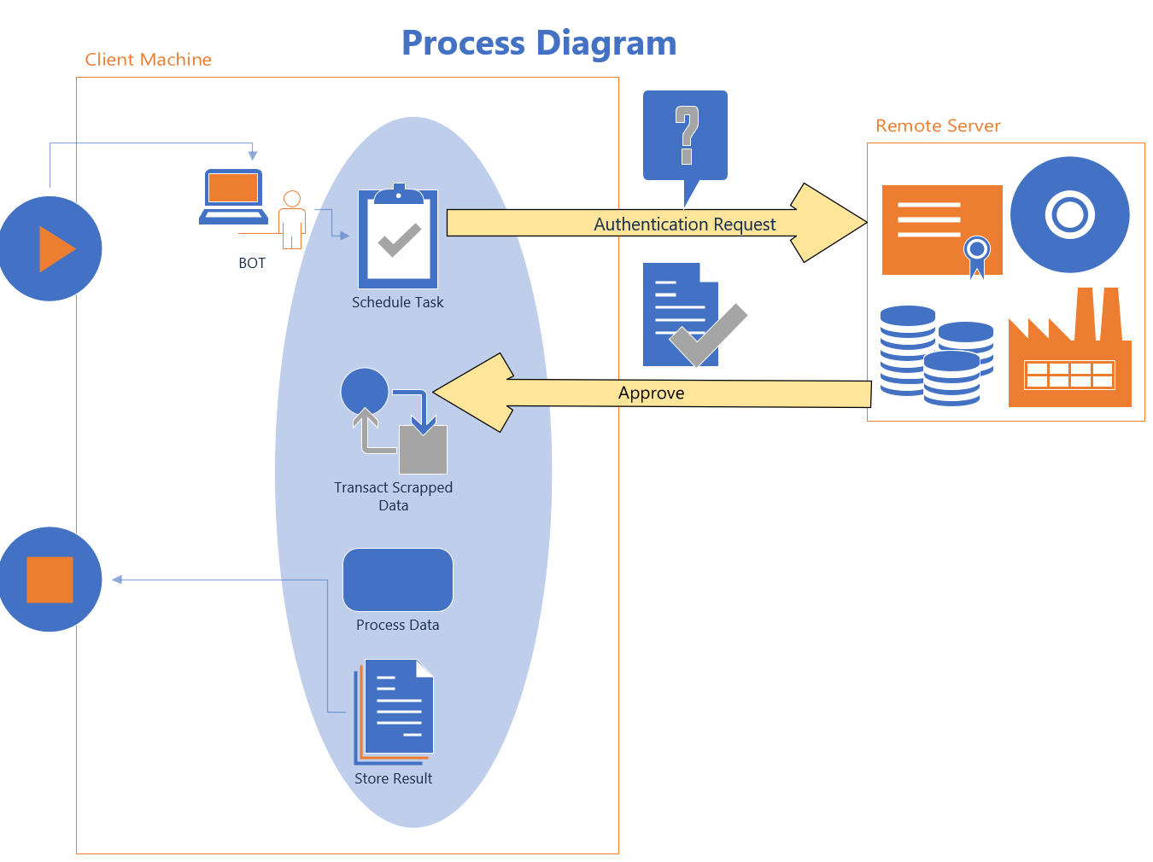

## **As -IS Process Description Step by Step in detail**

1. Sending Authentication Request to the Remote Machine for Server Connectivity.
2. Authentication Request Approved.
3. Starts Scraping Desktop\Web application based on the requirement.
4. Scrapped data processes.
5. Processed data stored into the local machine.

## **In-Scope**

To enable execution of job on the remote server using the ui path bot

The **objective** of this project is to **automate**

* Sending Authentication Request from the Local Machine to the Remote Machine for Server Connectivity.
* Authentication Request Approved.
* Opening an application in remote system and get data from website or some a
* Calculator – calculate and show result in the Local system
* Notepad - read text and display on local system
* Close the connection with the Remote Machine

## **Out-of-Scope**

Data Encryption and decryption during data processing.

# **Functional Requirements**

|  |  |
| --- | --- |
| **ID** | **Requirement Description** |
| FR-001 | Establishing Connection between Client and Server |
| FR-002 | Open an Application/Calculator/Notepad in Remote System |
| FR-003 | Scraping and Processing the Data |
| FR-004 | Displaying the Result in the Local System |
| FR-005 | Close the connection |

## **FR-001:** Establishing Connection between Client and Server

|  |  |
| --- | --- |
| **Goal** | The bot is able to establish Connection between Client and Server |
| **Pre-Condition** | 1. VNC Client in Local Machine 2. VNC Server in Remote Machine |
| **Flow** | 1. Sending Authentication Request to the Remote Machine for Server Connectivity. 2. Authentication Request Approved and connection established. |
| **Post-Condition** | Connection between Client and Server Established successfully. |

## **C:\julie\RPA Programs\Group 1 - Computer Vision\CV Project Delliverables\VNC viewer.jpg**

## **FR-002: Open an Application/Calculator/Notepad in Remote System**

|  |  |
| --- | --- |
| **Goal** | The bot is able to Open an Application/Calculator/Notepad in Remote System |
| **Pre-Condition** | The connection between Local and Remote machine should be established |
| **Flow** | 1. Receives the Input from the User 2. Opens an Application/Calculator/Notepad |
| **Post-Condition** | Successfully opens the application |

## 

## **FR-003: Scraping and Processing the Data**

|  |  |
| --- | --- |
| **Goal** | The bot is able to Scrape and Process the Data |
| **Pre-Condition** | Specific Appliication should be opened |
| **Flow** | 1. Enter the input data 2. Scraping and Processing the Data |
| **Post-Condition** | Successfully Processed the data |

## **FR-004: Displaying the Result in the Local System**

|  |  |
| --- | --- |
| **Goal** | The bot is able to Display the Result in the Local System |
| **Pre-Condition** | Processing the data should be completed |
| **Flow** | 1. Displays the result in Notepad/Output panel/Message box |
| **Post-Condition** | Successfully Displayed the result in local system |

## **FR-005: Close the connection**

|  |  |
| --- | --- |
| **Goal** | The bot is able to Close the connection |
| **Pre-Condition** | Result should be displayed in the local system |
| **Flow** | Close the connection between local machine and remote machine |
| **Post-Condition** | Successfully Closed the connection |

# **Non-Functional Requirements**

|  |  |
| --- | --- |
| **ID** | **Requirement** |
| NFR | Need to add PDF and Email Automation in our BOT. |

# **Glossary**

|  |  |
| --- | --- |
| **Term** | **Explanation** |
|  |  |
| VNC | VNC Viewer |
| API | Application Programming interface |
| CV | Computer Vision Package |
|  |  |
|  |  |
|  |  |

# **References**

|  |  |
| --- | --- |
| **Name** | **Link** |
| Google Drive | https://drive.google.com/drive/folders/1Yyg6UFKl3rdWJQAjOBG5nChmTRmeetUW?usp=sharing |
| GitHub | https://github.com/shailaja-sunil/ComputerVisionUsingUIPath.git |
|  |  |
|  |  |

# **Appendix**